WCP Product Research Tool Design Prototype V2

# Login Page:

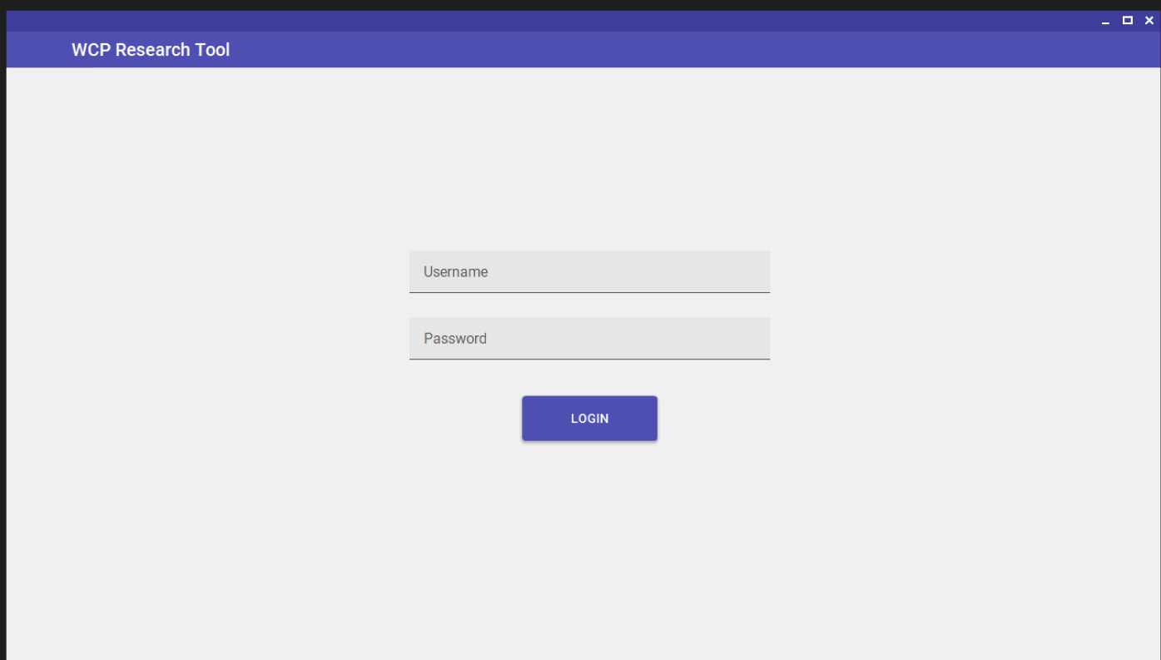

Main Page:  
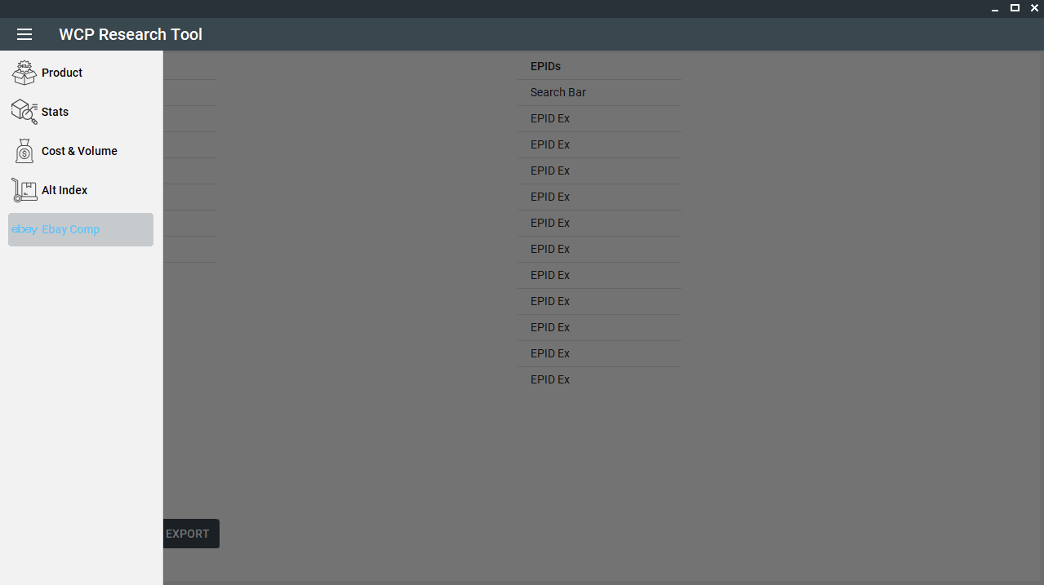

## Product Tab

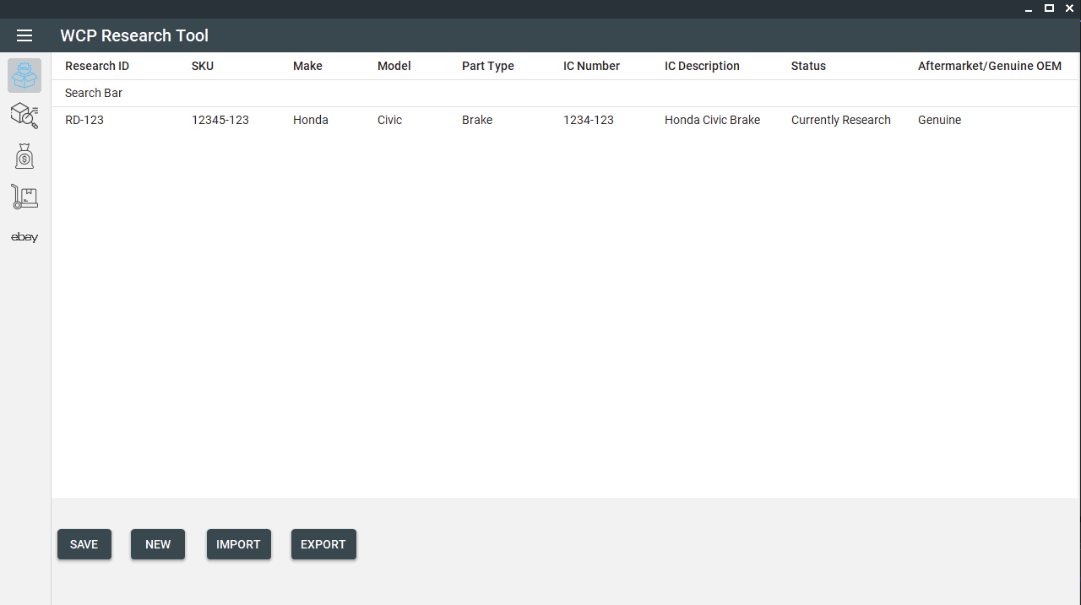

## Stats Tab

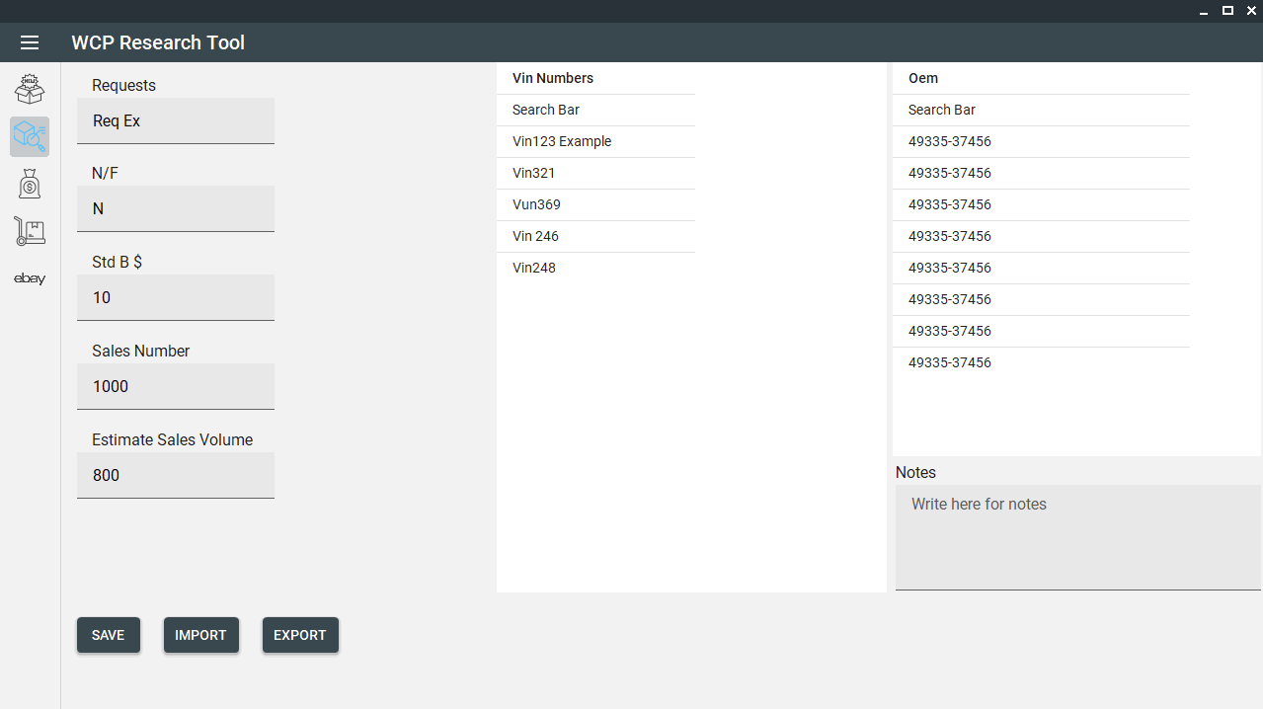

## Cost & Volume Tab

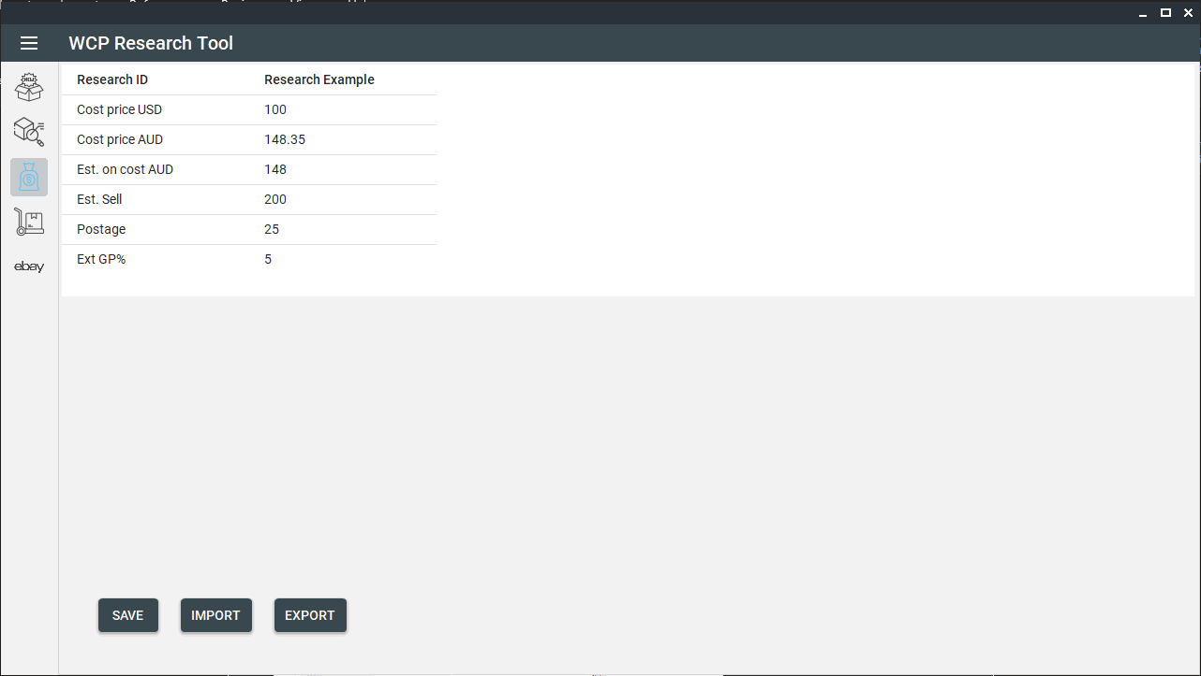

## Alternate Index Detail Tab

## Ebay Tab